About Lama Gursam  Lama Gursam is a respected master of the art of meditation. He began his studies in Buddhism at the age of six in a Monastery in Tso Pema, India. A warm and experienced Tibetan Buddhist teacher, he spends each year in a continuous teaching schedule with several months in India and Nepal in retreat and leading pilgrimages to historic spots of the Buddhist tradition.  Meditation and Compassion are at the core of his teachings.  Contact & Information: tibeteventsssm@gmail.com, www.jadewellnessstudio.com  677 Queen St. East; Sault Ste. Marie, ON; T: 705-257-7707 | 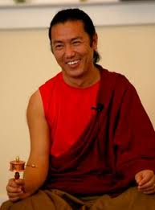
YOGI LAMA GURSAM CALENDAR OF EVENTS 2014
Date | Tues  Aug 19 | Wed  Aug 20 | Thurs  Aug 21 | Fri  Aug 22 | Sat  Aug 23 | Sun  Aug 24
Event | The Story of Milarepa | Sangha Members  Meditation &  Q & As | Animal Blessing | Potluck Dinner  Fundraiser | Meditation Instruction | Vajrapani Empowerment  (light lunch provided)
Location | Jade Wellness | Jade Wellness | Bellevue Park  Covered Picnic Area | RSVP Attendance for directions | Jade Wellness | Jade Wellness
Time | 7-9 pm | 7-9 pm | 7-8:30 pm | 7-9 pm | 1-4 pm | 9:30-4 pm
Suggested*  Donation | $20 | $10 | $20 | One Small Dish  $10 | $40 | $40

*No one will be turned away for lack of funds!

